**Project Report**

**On**

**ONLINE BOOKS STORES**

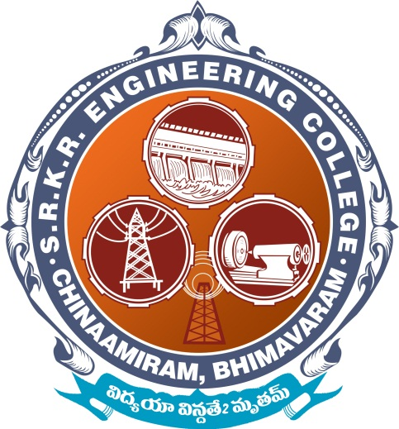

**SUBMITTED BY**

Miss. K.Lavanya Devi Regd. No: 670751041

Mr. K.Lakshmana Rao Regd. No: 670751042

Miss. K.Lavanya Devi Regd. No: 670751043

Mr. K.Lakshmana Rao Regd. No: 670751044

Mr. K.Lakshmana Rao Regd. No: 670751045

**DEPARTMENT OF COMPUTER SCIENCE AND ENGINEERING**

**S.R.K.R ENGINEERING COLLEGE**

**CHINA-AMIRAM, BHIMAVARAM**

**DEPARTMENT OF COMPUTER SCIENCE AND ENGINEERING**

**S.R.K.R ENGINEERING COLLEGE**

**(Affiliate to Andhra University)**



**CERTIFICATE**

This is to certify that the project entitled “**Online Book Stores**” is the confide work of Mr. K.Lakshmana Rao with Regd. No: 670751042 who carried out the work and submitted during the year 2009-2010.

Lecturer-in-charge

|  |  |
| --- | --- |
| K V Krishnam Raju  Associate Professor  Department of CSE,  SRKR Engineering College,  Bhimavaram. | S S N Raju  Assistant Professor  Department of CSE,  SRKR Engineering College,  Bhimavaram. |